Question 1

Q1.1: Is the first frog in the data set a male or a female? Male
Q1.2: How long is the femur of the 7th frog in the data set? 30.37 mm
Q1.3 (Challenge): What is the snout-vent length of the 12th frog in the data set? 53.90 mm
Q1.4: Make a histogram of the femur lengths of females in B. madagascariensis.
Figure 1.4. Femur lengths of 15 female B. madagascariensis in museum collections in the US.
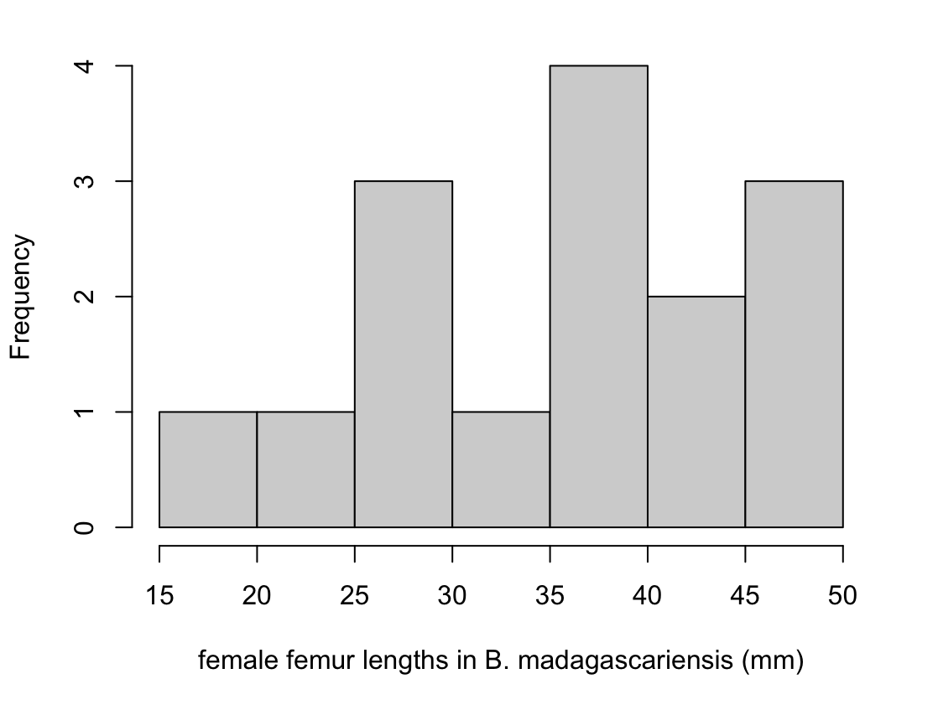

Q1.5: Report the results of our t-test asking “Are the mean femur lengths of male and female B. madagascariensis different?” The mean femur length in females was greater than that in males (35.1 mm vs 28.5 mm; Welch’s t-test, t = 2.56, df = 18.1, p = 0.0198).
Q1.6: Provide a figure to illustrate the results of your analysis.
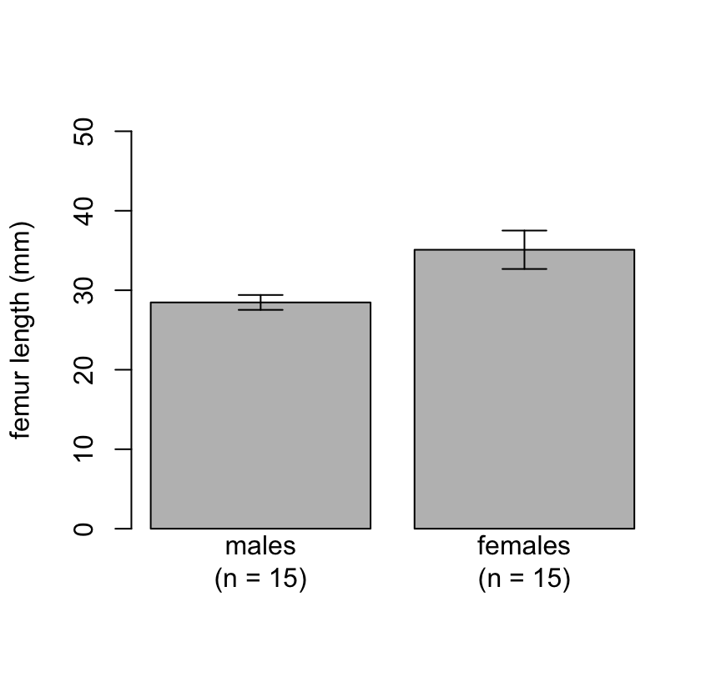
Figure 1.6. Mean femur lengths of male and female B. madagascariensis in museum collections in the US. Error bars show standard errors.
Question 2

Q2.1: What is the femur length of the frog in row 2 of the P. paradoxa data set? 27.96 mm
Q2.2: Is the most massive specimen in the data for this species a male or a female? Female
Q2.3 (Challenge): What is the mean mass of frogs in this data set? 16.98 g
Q2.4: Do the femur lengths of males and females appear to be roughly normally distributed within the sexes? Yes – or, at least, they look close to me!
Q2.5: Report the result of your t-test clearly and concisely. The mean femur length in females was greater than that in males (27.1 mm vs 24.5 mm; one-sided Welch’s t-test, t = 2.97, df = 27.9, p = 0.0030).

Q2.6: Provide a figure to illustrate your result.
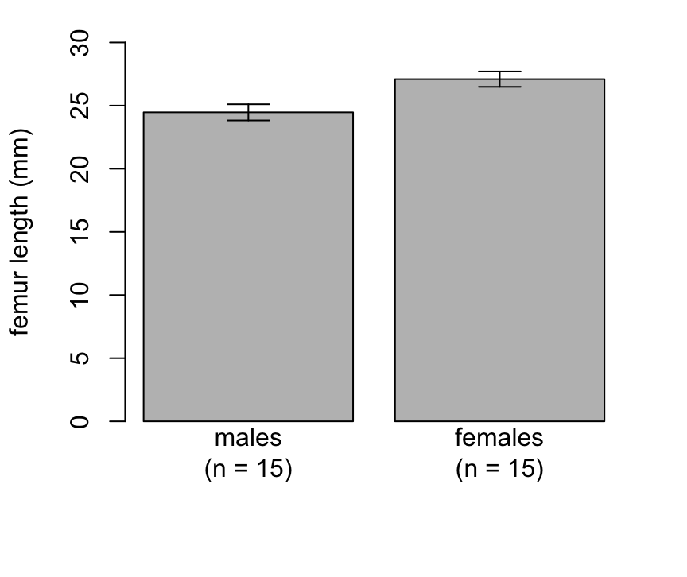
Figure 2.6. Mean femur lengths of male and female P. paradoxa in museum collections in the US. Error bars show standard errors.
Question 3

Q3.1: Should this be a one-tailed test or a two-tailed test? One-tailed
Q3.2: Report the results of your analysis clearly and concisely. We found marginally significant evidence that female D. auratus were more massive that males (2.60 g vs 2.15 g; one-sided Welch’s t-test, t = 1.42, df = 22.1, p = 0.0843).
Q3.3: Provide a figure to illustrate your results.
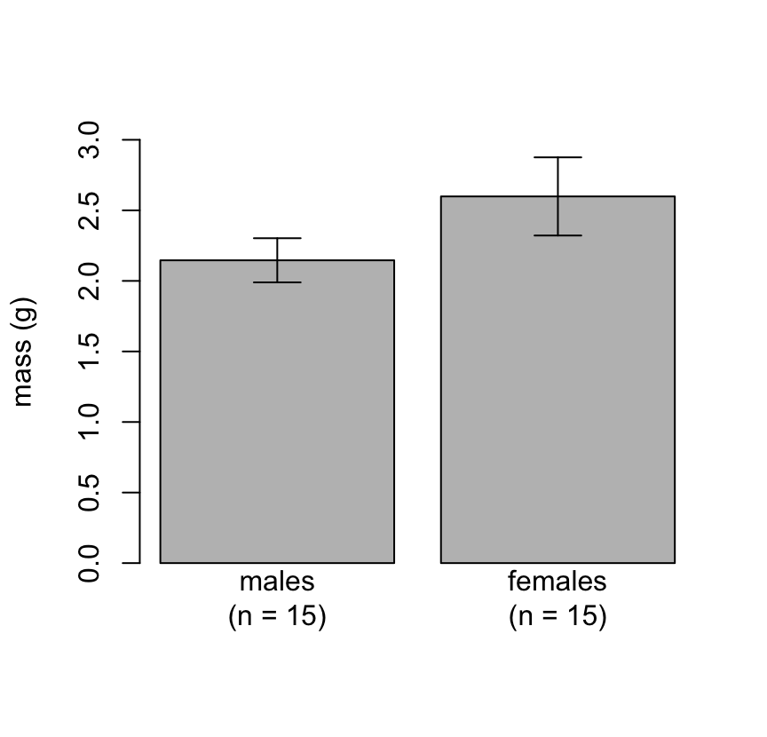
Figure 3.3. Mean mass of male and female D. auratus in museum collections in the US. Error bars show standard errors.

Question 4

Q4.1: Before you look at Tysall and colleague’s data, do you expect the latency to mate to be normally distributed within groups? Why or why not. No. Normal distributions have long tails in both directions. Latency cannot be less than zero, so the distribution of latencies cannot have a long left tail. And, it is truncated at 2 hours on the right, so it cannot have a long right tail. So, unless all of the latencies are far from zero and far from 2 hours (ie, no flies mated very quickly and none failed to mate), the distribution of latencies cannot be normal. More generally, waiting times tend to be right-skewed. This is true because, if the probability of the event occurring is constant, then many events will occur early in trials because there are lots of individuals waiting for events, and fewer will occur later in trials when most individuals have already experienced the event and are no longer waiting.
Q4.2: What were the latencies to mate for the first and third flies in an.flies? 120 min and 2 min, respectively.
Q4.3: Report the results of your Wilcoxon test clearly and concisely. We found no difference in latency to mate between flies anaesthetised with ice or CO2 (Wilcoxon rank sum test, p = 0.7974).
Q4.4: Provide a figure to illustrate your results.
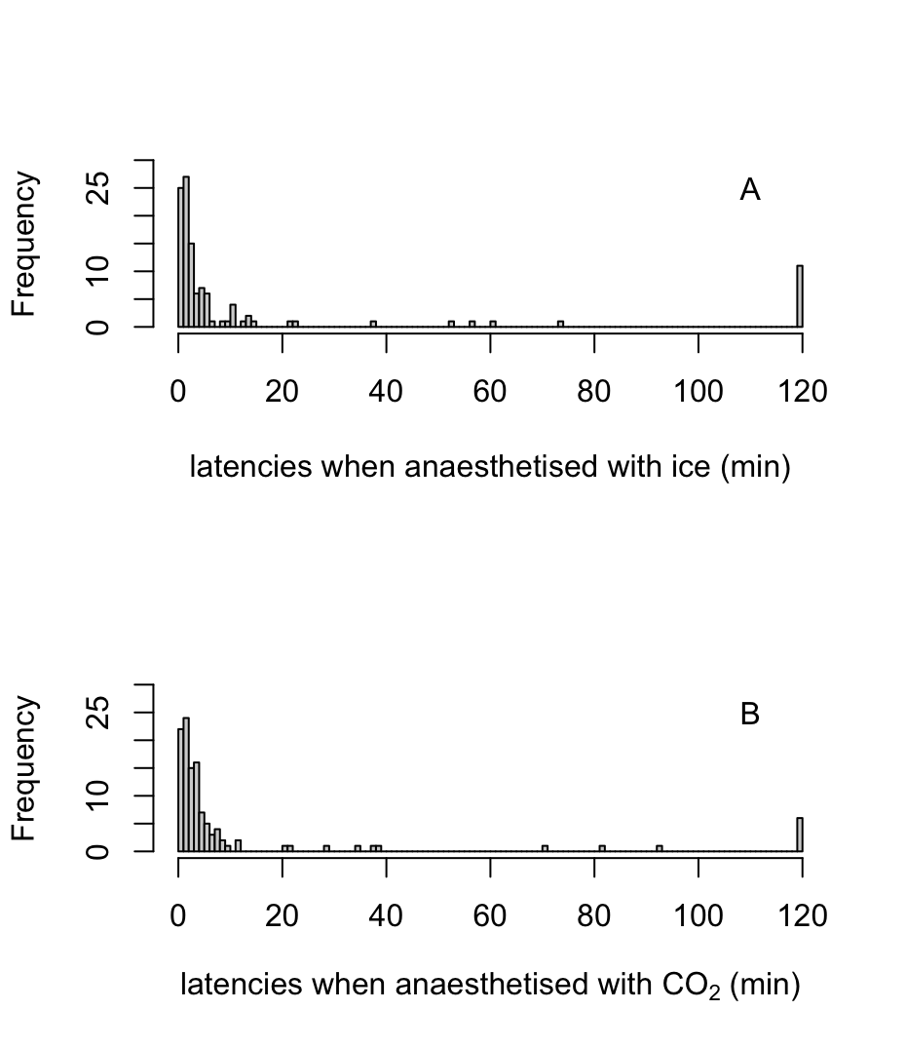
Figure 4.4. Latencies to mate in Drosophila anaesthetised with (A) ice or (B) CO₂.

